Network Task

Task Description:
1.Get me the IP address of a particular domain (guvi.in). How do I find my CPU/memory usage of my server?. Test the connectivity between 2 nodes?

OUTPUT:
1.IP address of a particular domain (guvi.in):
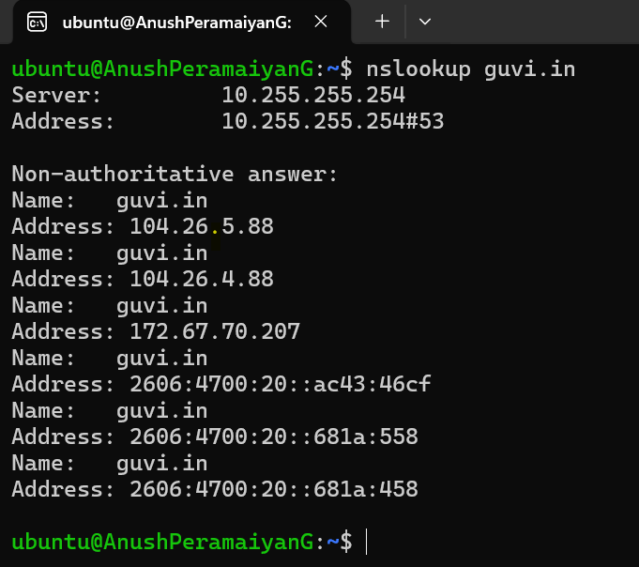
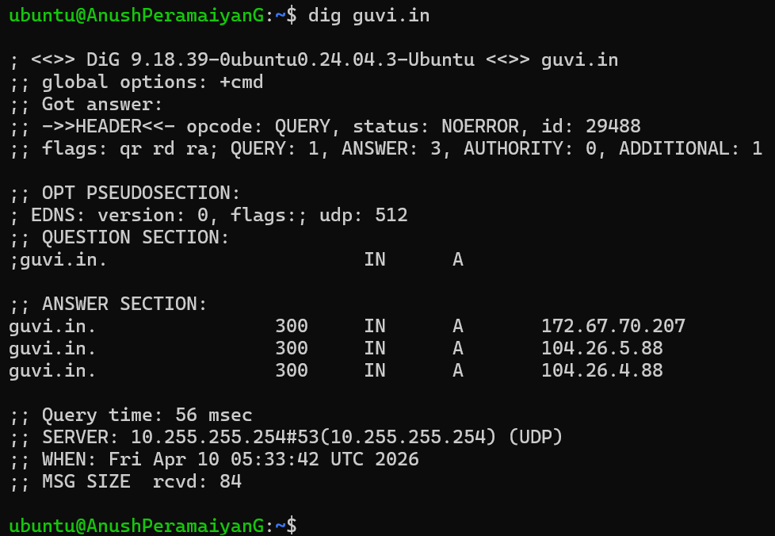
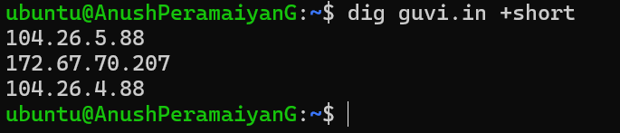
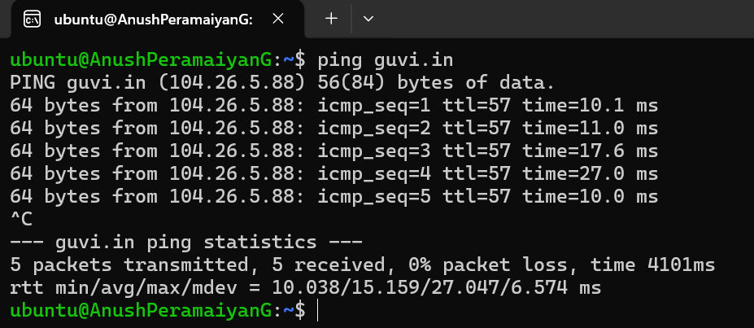

2. My CPU/memory usage of my server:
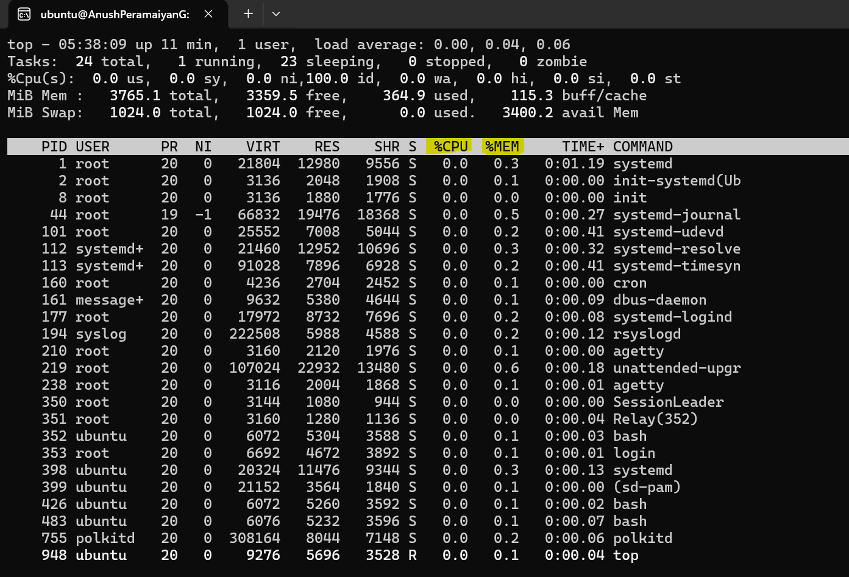
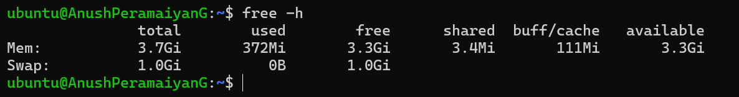
3. Test the connectivity between 2 nodes:
Basic connectivity (ICMP):
Node1 Public IP : 13.233.83.126
Node2 Public IP : 13.201.38.13

ping & traceroute status from Node1 to Node2:
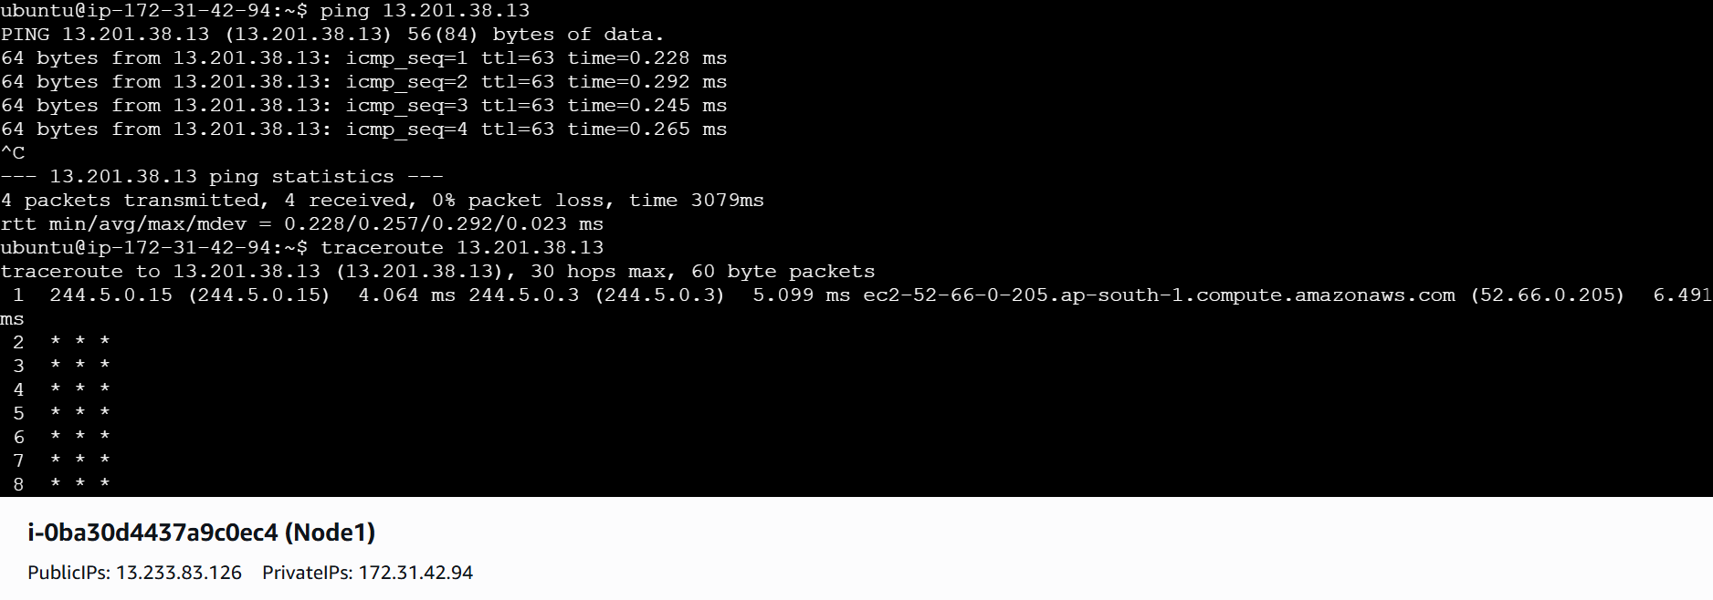

ping & traceroute status from Node2 to Node1:
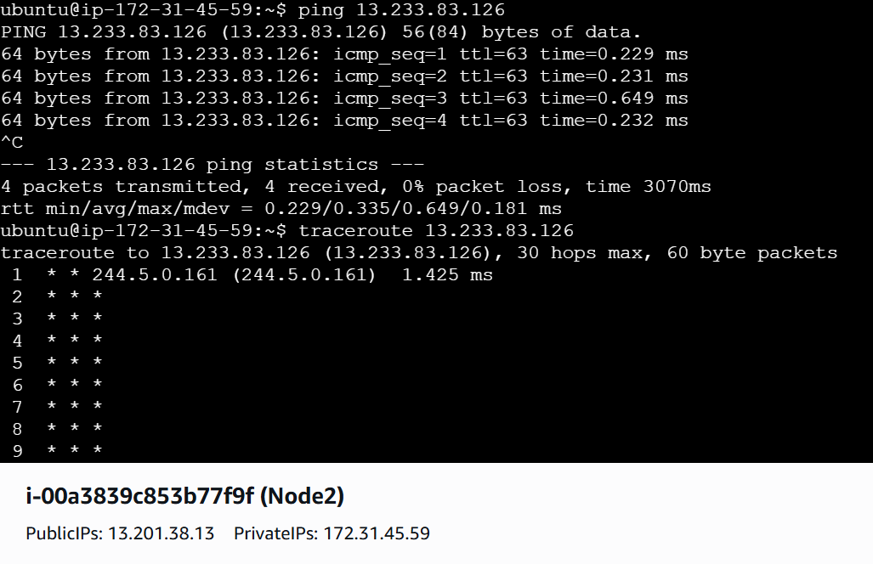
2.I have deployed an application in guvi.com:9000, and logs show my app is running, but I’m unable to view the page. Check whether my port is open or not ?

OUTPUT:
- Check the port status using Telnet
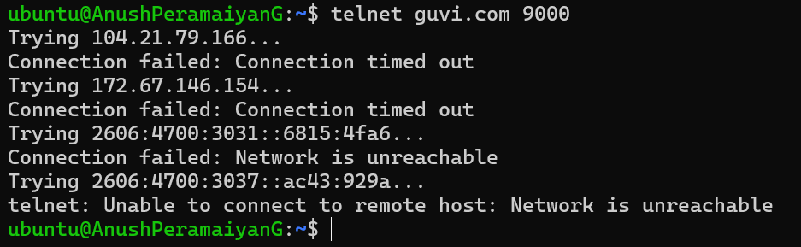

- Check the port status using curl:
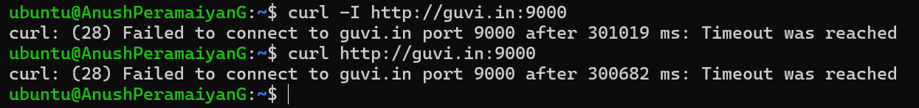
- Check the Port status using netcat:

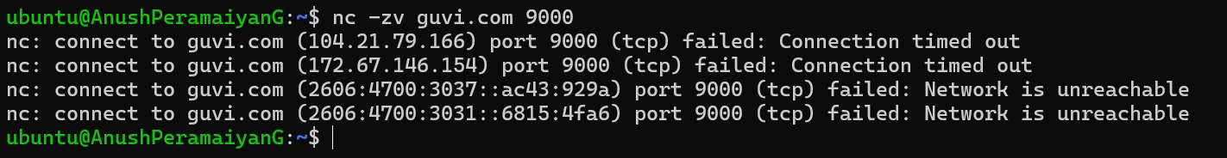

guvi.com:9000 URL checks from browser 